Mini-project: Front_end:

# HOME PAGE:

<!DOCTYPE html>

<html lang="en">

<head>

  <meta charset="UTF-8" />

  <meta name="viewport" content="width=device-width, initial-scale=1.0"/>

  <title>Home - BlueEdge Solutions</title>

  <!-- Bootstrap CSS -->

  <link href="https://cdn.jsdelivr.net/npm/bootstrap@5.3.2/dist/css/bootstrap.min.css" rel="stylesheet">

  <!-- Font Awesome -->

  <link rel="stylesheet" href="https://cdnjs.cloudflare.com/ajax/libs/font-awesome/6.5.0/css/all.min.css">

  <!-- Bootstrap Icons (for arrow icon) -->

  <link rel="stylesheet" href="https://cdn.jsdelivr.net/npm/bootstrap-icons@1.11.1/font/bootstrap-icons.css">

  <!-- Custom CSS -->

  <link rel="stylesheet" href="home.css">

  <style>

    body { padding-top: 70px; }

    .project-carousel img { max-height: 60vh; object-fit: cover; }

    /* Back-to-top button style */

    #scrollTopBtn {

    display: none;

    position: fixed;

    bottom: 30px;

    right: 30px;

    z-index: 9999;

    width: 50px;

    height: 50px;

    border: none;

    border-radius: 50%;

    background-color: #0d6efd;

    color: white;

    font-size: 22px;

    box-shadow: 0 4px 10px rgba(0, 0, 0, 0.3);

    transition: opacity 0.4s ease;

    }

    #scrollTopBtn:hover {

  background-color: #0b5ed7;

  }

  </style>

</head>

<body>

  <!-- Navbar -->

  <nav class="navbar navbar-expand-lg navbar-dark bg-dark fixed-top">

    <div class="container">

      <a class="navbar-brand d-flex align-items-center" href="home.html">

        <img src="blue.webp"

     alt="BlueEdge Solutions"

     width="40" height="40"

     class="me-2 rounded-circle">

        <span>BlueEdge Solutions</span>

      </a>

      <button class="navbar-toggler" type="button" data-bs-toggle="collapse" data-bs-target="#navbarNav">

        <span class="navbar-toggler-icon"></span>

      </button>

      <div class="collapse navbar-collapse justify-content-end" id="navbarNav">

  <ul class="navbar-nav">

    <li class="nav-item">

      <a class="nav-link active" href="home.html">

        <i class="fas fa-house me-2"></i>Home

      </a>

    </li>

    <li class="nav-item">

      <a class="nav-link" href="about.html">

        <i class="fas fa-user-tie me-2"></i>About

      </a>

    </li>

    <li class="nav-item">

      <a class="nav-link" href="contact.html">

        <i class="fas fa-paper-plane me-2"></i>Contact

      </a>

    </li>

  </ul>

</div>

  </nav>

  <!-- Projects Carousel Section -->

  <section class="container py-5">

    <h2 class="text-center fw-bold mb-4">Our Projects</h2>

    <div id="projectCarousel" class="carousel slide project-carousel" data-bs-ride="carousel" data-bs-interval="3000">

      <!-- indicators -->

      <div class="carousel-indicators">

        <button type="button" data-bs-target="#projectCarousel" data-bs-slide-to="0" class="active" aria-current="true" aria-label="Slide 1"></button>

        <button type="button" data-bs-target="#projectCarousel" data-bs-slide-to="1" aria-label="Slide 2"></button>

        <button type="button" data-bs-target="#projectCarousel" data-bs-slide-to="2" aria-label="Slide 3"></button>

      </div>

      <!-- inner -->

      <div class="carousel-inner text-center">

        <div class="carousel-item active">

          <img src="https://images.unsplash.com/photo-1521737604893-d14cc237f11d?w=1200&h=500&fit=crop"

               class="d-block w-100 rounded shadow-sm" alt="Web Development">

          <div class="carousel-caption d-none d-md-block bg-dark bg-opacity-50 rounded p-3">

            <h5 class="fw-bold text-white">Web Development</h5>

            <p class="text-light">Building fast, modern, and responsive websites that bring your ideas to life.</p>

          </div>

        </div>

        <div class="carousel-item">

          <img src="https://images.unsplash.com/photo-1522202176988-66273c2fd55f?w=1200&h=500&fit=crop"

               class="d-block w-100 rounded shadow-sm" alt="UI UX Design">

          <div class="carousel-caption d-none d-md-block bg-dark bg-opacity-50 rounded p-3">

            <h5 class="fw-bold text-white">UI/UX Design</h5>

            <p class="text-light">Designing smooth, engaging, and user-friendly interfaces for better digital experiences.</p>

          </div>

        </div>

        <div class="carousel-item">

          <img src="https://images.unsplash.com/photo-1504384308090-c894fdcc538d?w=1200&h=500&fit=crop"

               class="d-block w-100 rounded shadow-sm" alt="Digital Solutions">

          <div class="carousel-caption d-none d-md-block bg-dark bg-opacity-50 rounded p-3">

            <h5 class="fw-bold text-white">Digital Solutions</h5>

            <p class="text-light">Providing innovative solutions that help businesses grow and connect online effectively.</p>

          </div>

        </div>

      </div>

      <!-- controls -->

      <button class="carousel-control-prev" type="button" data-bs-target="#projectCarousel" data-bs-slide="prev">

        <span class="carousel-control-prev-icon" aria-hidden="true"></span>

        <span class="visually-hidden">Previous</span>

      </button>

      <button class="carousel-control-next" type="button" data-bs-target="#projectCarousel" data-bs-slide="next">

        <span class="carousel-control-next-icon" aria-hidden="true"></span>

        <span class="visually-hidden">Next</span>

      </button>

    </div>

  </section>

  <!-- Features Section -->

<section class="features">

  <h2>Why Choose Us</h2>

  <div class="grid">

    <div class="card">

      <img src="https://images.unsplash.com/photo-1521737604893-d14cc237f11d?auto=format&fit=crop&w=800&q=80" alt="Creative Design">

      <h3>Creative Design</h3>

      <p>Our designs are modern, unique, and tailored to your brand’s identity.</p>

    </div>

    <div class="card">

      <img src="https://images.unsplash.com/photo-1556155092-8707de31f9c4?auto=format&fit=crop&w=800&q=80" alt="Latest Technology">

      <h3>Latest Technology</h3>

      <p>We use cutting-edge tools to deliver fast, responsive, and scalable solutions.</p>

    </div>

    <div class="card">

      <img src="https://images.unsplash.com/photo-1557804506-669a67965ba0?auto=format&fit=crop&w=800&q=80" alt="24/7 Support">

      <h3>24/7 Support</h3>

      <p>Our team is always available to assist you with any queries or issues.</p>

    </div>

  </div>

</section>

<!-- Back to Top Button -->

<button id="scrollTopBtn" class="btn btn-primary rounded-circle">

  <i class="bi bi-arrow-up"></i>

</button>

­­­­­­­  <!-- Welcome Modal -->

  <div class="modal fade" id="welcomeModal" tabindex="-1">

    <div class="modal-dialog modal-dialog-centered">

      <div class="modal-content">

        <div class="modal-header bg-primary text-white">

          <h5 class="modal-title">Welcome to My Site!</h5>

          <button type="button" class="btn-close" data-bs-dismiss="modal"></button>

        </div>

        <div class="modal-body text-center">

          <p>Hi,💫<br>Thanks for visiting my BlueEdge Solutions ❤️</p>

        </div>

      </div>zzz

    </div>

  </div>

  <!-- Footer -->

  <footer class="mt-5 pt-5 pb-3">

    <div class="container">

      <div class="row text-center text-md-start">

        <div class="col-md-3 mb-4 text-center">

          <img src="blue.webp" alt="BlueEdge Logo" width="80" height="80" class="rounded-circle mb-2 logo-hover">

          <h5 class="fw-bold text-uppercase">BlueEdge Solutions</h5>

          <p class="small">Innovate • Create • Deliver</p>

        </div>

        <div class="col-md-3 mb-4">

          <h5 class="fw-bold">Contact Info</h5>

          <p>Email: <a href="mailto:leo@gmail.com" class="text-light">leo@gmail.com</a></p>

          <p>Phone: +91 98765 43210</p>

          <p>Location: Pune, India</p>

        </div>

        <div class="col-md-3 mb-4">

          <h5 class="fw-bold">Find Me</h5>

          <iframe

            src="https://www.google.com/maps/embed?pb=!1m18!1m12!1m3!1d3783.345678876543!2d73.85674391516994!3d18.520430887410825!2m3!1f0!2f0!3f0!3m2!1i1024!2i768!4f13.1!3m3!1m2!1s0x3bc2c0659d5d5d5d%3A0xd3c3d5d5d5d5d5d5!2sPune%2C%20Maharashtra!5e0!3m2!1sen!2sin!4v1697541234567"

            width="100%" height="150" style="border:0;" allowfullscreen="" loading="lazy">

          </iframe>

        </div>

        <div class="col-md-3 mb-4 text-center text-md-start">

          <h5 class="fw-bold">Follow Us</h5>

          <div class="d-flex justify-content-center justify-content-md-start mt-2">

            <a href="#" class="text-white me-3"><i class="fab fa-facebook fa-lg"></i></a>

            <a href="#" class="text-white me-3"><i class="fab fa-twitter fa-lg"></i></a>

            <a href="#" class="text-white me-3"><i class="fab fa-linkedin fa-lg"></i></a>

            <a href="#" class="text-white"><i class="fab fa-instagram fa-lg"></i></a>

          </div>

        </div>

      </div>

      <hr class="border-light">

      <div class="text-center mt-3"><small>&copy; 2025 BlueEdge Solutions. All rights reserved.</small></div>

    </div>

  </footer>

  <!-- Bootstrap JS -->

  <script src="https://cdn.jsdelivr.net/npm/bootstrap@5.3.2/dist/js/bootstrap.bundle.min.js"></script>

  <!-- Auto-open welcome modal + Back-to-top -->

  <script>

    window.addEventListener('load', () => {

      // Show welcome modal

      const welcomeModalEl = document.getElementById('welcomeModal');

      if (welcomeModalEl) {

        const welcomeModal = new bootstrap.Modal(welcomeModalEl);

        welcomeModal.show();

      }

      });

  // Get the button

  const scrollBtn = document.getElementById("scrollTopBtn");

  // Show the button after scroll

  window.addEventListener("scroll", () => {

    if (window.scrollY > 200) {

      scrollBtn.style.display = "block";

      scrollBtn.style.opacity = "1";

    } else {

      scrollBtn.style.opacity = "0";

      scrollBtn.style.display = "none";

    }

  });

  // Smooth scroll to top

  scrollBtn.addEventListener("click", () => {

    window.scrollTo({ top: 0, behavior: "smooth" });

  });

</script>

</body>

</html>

# ABOUT PAGE:

<!DOCTYPE html>

<html lang="en">

<head>

    <meta charset="UTF-8">

    <meta name="viewport" content="width=device-width, initial-scale=1.0">

    <title>About - BlueEdge Solutions</title>

    <!-- Bootstrap CSS -->

    <link href="https://cdn.jsdelivr.net/npm/bootstrap@5.3.2/dist/css/bootstrap.min.css" rel="stylesheet">

    <!-- Font Awesome Icons -->

    <link rel="stylesheet" href="https://cdnjs.cloudflare.com/ajax/libs/font-awesome/6.5.0/css/all.min.css">

    <!-- Custom CSS -->

    <link rel="stylesheet" href="home.css">

</head>

<body>

    <!-- Navbar Section -->

    <nav class="navbar navbar-expand-lg navbar-dark bg-dark fixed-top">

        <div class="container">

            <!-- Website Logo & Title -->

            <a class="navbar-brand d-flex align-items-center" href="home.html">

                <img src="blue.webp" alt="BlueEdge Solutions Logo" width="40" height="40" class="me-2 rounded-circle">

                <span>BlueEdge Solutions</span>

            </a>

            <!-- Mobile Menu Toggle Button -->

            <button class="navbar-toggler" type="button" data-bs-toggle="collapse" data-bs-target="#navbarNav">

                <span class="navbar-toggler-icon"></span>

            </button>

            <!-- Navigation Menu Links -->

            <div class="collapse navbar-collapse justify-content-end" id="navbarNav">

                <ul class="navbar-nav">

                    <li class="nav-item">

                        <a class="nav-link active" href="home.html">

                            <i class="fas fa-house me-2"></i>Home

                        </a>

                    </li>

                    <li class="nav-item">

                        <a class="nav-link" href="about.html">

                            <i class="fas fa-user-tie me-2"></i>About

                        </a>

                    </li>

                    <li class="nav-item">

                        <a class="nav-link" href="contact.html">

                            <i class="fas fa-paper-plane me-2"></i>Contact

                        </a>

                    </li>

                </ul>

            </div>

        </div>

    </nav>

    <!-- About Section -->

    <section class="container mt-5 pt-5">

        <div class="row align-items-center">

            <!-- About Text -->

            <div class="col-md-6">

                <h2 class="fw-bold text-primary mb-3">About BlueEdge Solutions</h2>

                <p class="lead">

                    Welcome to <b>BlueEdge Solutions</b> — where creativity meets technology.

                    We design and develop beautiful, responsive, and user-friendly websites

                    that help brands stand out in the digital world.

                </p>

                <p>

                    Our dedicated team combines modern design trends, efficient coding,

                    and innovative thinking to deliver powerful web experiences.

                </p>

                <!-- Services List -->

                <ul class="list-unstyled">

                    <li>➡ Custom Web Development</li>

                    <li>➡ Responsive & Mobile-First Design</li>

                    <li>➡ Branding & Digital Strategy</li>

                </ul>

                <!-- Contact Button -->

                <a href="contact.html" class="btn btn-primary mt-3">

                    <i class="fas fa-paper-plane me-2"></i> Contact Us

                </a>

            </div>

            <!-- Image Section -->

            <div class="col-md-6 text-center">

                <img src="https://images.unsplash.com/photo-1522202176988-66273c2fd55f?auto=format&fit=crop&w=600&q=80"

                     alt="Team working on project"

                     class="img-fluid rounded-4 shadow-lg">

            </div>

        </div>

    </section>

    <!-- Our Values Section -->

    <section class="container py-5 text-center">

        <h3 class="fw-bold text-primary mb-4">Our Core Values</h3>

        <div class="row g-4">

            <!-- Value Card 1 -->

            <div class="col-md-3 col-sm-6">

                <div class="p-4 bg-secondary-subtle border border-secondary rounded-4 shadow-sm h-100">

                    <i class="fas fa-handshake fa-2x text-secondary mb-3"></i>

                    <h6 class="fw-bold text-secondary">Integrity</h6>

                    <p class="text-dark mb-0">We believe in honesty, transparency, and partnerships.</p>

                </div>

            </div>

            <!-- Value Card 2 -->

            <div class="col-md-3 col-sm-6">

                <div class="p-4 bg-primary text-white rounded-4 shadow-sm h-100">

                    <i class="fas fa-lightbulb fa-2x text-warning mb-3"></i>

                    <h6 class="fw-bold text-white">Innovation</h6>

                    <p class="mb-0">We bring creative thinking and new technology.</p>

                </div>

            </div>

            <!-- Value Card 3 -->

            <div class="col-md-3 col-sm-6">

                <div class="p-4 bg-info text-white rounded-4 shadow-sm h-100">

                    <i class="fas fa-users fa-2x text-light mb-3"></i>

                    <h6 class="fw-bold text-white">Teamwork</h6>

                    <p class="mb-0">We collaborate for the best results.</p>

                </div>

            </div>

            <!-- Value Card 4 -->

            <div class="col-md-3 col-sm-6">

                <div class="p-4 bg-warning-subtle border border-warning rounded-4 shadow-sm h-100">

                    <i class="fas fa-star fa-2x text-warning mb-3"></i>

                    <h6 class="fw-bold text-dark">Excellence</h6>

                    <p class="text-muted mb-0">We aim for perfection in every project.</p>

                </div>

            </div>

        </div>

    </section>

    <!-- Team Section -->

    <section class="py-5 bg-light">

        <div class="container text-center">

            <h3 class="fw-bold text-primary mb-4">Meet Our Team</h3>

            <div class="row g-4 justify-content-center">

                <!-- Member 1 -->

                <div class="col-md-3 col-sm-6">

                    <div class="card border-0 shadow-sm">

                        <img src="https://randomuser.me/api/portraits/women/44.jpg" class="card-img-top" alt="CEO">

                        <div class="card-body">

                            <h6 class="fw-bold mb-0">lolita</h6>

                            <p class="text-muted">Founder & CEO</p>

                        </div>

                    </div>

                </div>

                <!-- Member 2 -->

                <div class="col-md-3 col-sm-6">

                    <div class="card border-0 shadow-sm">

                        <img src="https://randomuser.me/api/portraits/men/46.jpg" class="card-img-top" alt="Designer">

                        <div class="card-body">

                            <h6 class="fw-bold mb-0">Arjun</h6>

                            <p class="text-muted">Lead Designer</p>

                        </div>

                    </div>

                </div>

                <!-- Member 3 -->

                <div class="col-md-3 col-sm-6">

                    <div class="card border-0 shadow-sm">

                        <img src="https://randomuser.me/api/portraits/men/65.jpg" class="card-img-top" alt="Developer">

                        <div class="card-body">

                            <h6 class="fw-bold mb-0">Karan</h6>

                            <p class="text-muted">Full-Stack Developer</p>

                        </div>

                    </div>

                </div>

            </div>

        </div>

    </section>

    <!-- Footer Section -->

    <footer class="mt-5 pt-5 pb-3">

        <div class="container">

            <div class="row text-center text-md-start">

                <!-- Logo -->

                <div class="col-md-3 mb-4 text-center">

                    <img src="blue.webp" alt="BlueEdge Logo" width="80" height="80"

                         class="rounded-circle mb-2 logo-hover">

                    <h5 class="fw-bold text-uppercase">BlueEdge Solutions</h5>

                    <p class="small">Innovate • Create • Deliver</p>

                </div>

                <!-- Contact Info -->

                <div class="col-md-3 mb-4">

                    <h5 class="fw-bold">Contact Info</h5>

                    <p>Email: <a href="mailto:leo@gmail.com" class="text-light">leo@gmail.com</a></p>

                    <p>Phone: +91 98765 43210</p>

                    <p>Location: Pune, India</p>

                </div>

                <!-- Google Map -->

                <div class="col-md-3 mb-4">

                    <h5 class="fw-bold">Find Me</h5>

                    <iframe

                        src="https://www.google.com/maps/embed?pb=!1m18!1m12!1m3!1d3783.345678876543!2d73.85674391516994!3d18.520430887410825!2m3!1f0!2f0!3f0!3m2!1i1024!2i768!4f13.1!3m3!1m2!1s0x3bc2c0659d5d5d5d%3A0xd3c3d5d5d5d5d5d5!2sPune%2C%20Maharashtra!5e0!3m2!1sen!2sin!4v1697541234567"

                        width="100%" height="150" style="border:0;" allowfullscreen loading="lazy">

                    </iframe>

                </div>

                <!-- Social Icons -->

                <div class="col-md-3 mb-4 text-center text-md-start">

                    <h5 class="fw-bold">Follow Us</h5>

                    <div class="d-flex justify-content-center justify-content-md-start mt-2">

                        <a href="#" class="text-white me-3"><i class="fab fa-facebook fa-lg"></i></a>

                        <a href="#" class="text-white me-3"><i class="fab fa-twitter fa-lg"></i></a>

                        <a href="#" class="text-white me-3"><i class="fab fa-linkedin fa-lg"></i></a>

                        <a href="#" class="text-white"><i class="fab fa-instagram fa-lg"></i></a>

                    </div>

                </div>

            </div>

            <hr class="border-light">

            <div class="text-center mt-3">

                <small>&copy; 2025 BlueEdge Solutions. All rights reserved.</small>

            </div>

        </div>

    </footer>

    <!-- Bootstrap JavaScript -->

    <script src="https://cdn.jsdelivr.net/npm/bootstrap@5.3.2/dist/js/bootstrap.bundle.min.js"></script>

</body>

</html>

# CONTACT PAGE:

<!DOCTYPE html>

<html lang="en">

<head>

  <!-- Basic Page Setup -->

  <meta charset="UTF-8">

  <meta name="viewport" content="width=device-width, initial-scale=1.0">

  <title>Home - BlueEdge Solutions</title>

  <!-- Bootstrap CSS -->

  <link href="https://cdn.jsdelivr.net/npm/bootstrap@5.3.2/dist/css/bootstrap.min.css" rel="stylesheet">

  <!-- Font Awesome Icons -->

  <link rel="stylesheet" href="https://cdnjs.cloudflare.com/ajax/libs/font-awesome/6.5.0/css/all.min.css">

  <!-- External CSS File -->

  <link rel="stylesheet" href="home.css">

  <style>

    /* Contact Section Background */

    section.contact-section {

      background: linear-gradient(135deg, #e3f2fd, #bbdefb);

      min-height: 100vh;

      display: flex;

      align-items: center;

      justify-content: center;

      padding: 60px 0;

    }

  </style>

</head>

<body>

  <!-- ======================= NAVBAR ======================= -->

<nav class="navbar navbar-expand-lg navbar-dark bg-dark fixed-top">

  <div class="container">

    <!-- Logo + Brand Name -->

    <a class="navbar-brand d-flex align-items-center" href="home.html">

      <img src="blue.webp" alt="BlueEdge Solutions Logo" width="40" height="40" class="me-2 rounded-circle">

      <span>BlueEdge Solutions</span>

    </a>

    <!-- Mobile Menu Toggle -->

    <button class="navbar-toggler" type="button" data-bs-toggle="collapse" data-bs-target="#navbarNav">

      <span class="navbar-toggler-icon"></span>

    </button>

    <!-- Navbar Links -->

    <div class="collapse navbar-collapse justify-content-end" id="navbarNav">

      <ul class="navbar-nav">

        <!-- Home Link -->

        <li class="nav-item">

          <a class="nav-link active" href="home.html">

            <i class="fas fa-house me-2"></i>Home

          </a>

        </li>

        <!-- About Link -->

        <li class="nav-item">

          <a class="nav-link" href="about.html">

            <i class="fas fa-user-tie me-2"></i>About

          </a>

        </li>

        <!-- Contact Link -->

        <li class="nav-item">

          <a class="nav-link" href="contact.html">

            <i class="fas fa-paper-plane me-2"></i>Contact

          </a>

        </li>

      </ul>

    </div>

  </div>

</nav>

<!-- ======================= CONTACT FORM SECTION ======================= -->

<section class="d-flex justify-content-center align-items-center min-vh-100 bg-light">

  <div class="container">

    <!-- Section Title -->

    <h2 class="text-center mb-4 fw-bold text-primary">Contact Me</h2>

    <div class="row justify-content-center">

      <div class="col-lg-8">

        <!-- Contact Card -->

        <div class="card shadow-lg border-0 rounded-4 overflow-hidden">

          <div class="row g-0 align-items-stretch">

            <!-- Left Side Image -->

            <div class="col-md-6">

              <img src="form.jpg"

                   alt="Contact Illustration"

                   class="img-fluid h-100 w-100"

                   style="object-fit: cover;">

            </div>

            <!-- Right Side Form -->

            <div class="col-md-6 bg-white">

              <div class="p-4 p-md-5 h-100 d-flex flex-column justify-content-center">

                <!-- Actual Form -->

                <form>

                  <!-- Name Field -->

                  <div class="mb-3">

                    <label for="name" class="form-label fw-semibold">Full Name</label>

                    <input type="text" class="form-control rounded-3" id="name" required>

                  </div>

                  <!-- Email Field -->

                  <div class="mb-3">

                    <label for="email" class="form-label fw-semibold">Email Address</label>

                    <input type="email" class="form-control rounded-3" id="email" required>

                  </div>

                  <!-- Message Field -->

                  <div class="mb-3">

                    <label for="message" class="form-label fw-semibold">Your Message</label>

                    <textarea class="form-control rounded-3" id="message"

                  </div>

                  <!-- Submit Button -->

                  <button type="submit" class="btn btn-primary w-100 py-2 rounded-3 fw-semibold">

                    Send Message

                  </button>

                </form>

              </div>

            </div>

          </div>

        </div>

        <!-- End of Contact Card -->

      </div>

    </div>

  </div>

</section>

<!-- ======================= FOOTER SECTION ======================= -->

<footer class="mt-5 pt-5 pb-3">

  <div class="container">

    <div class="row text-center text-md-start">

      <!-- Footer Logo -->

      <div class="col-md-3 mb-4 text-center">

        <img src="blue.webp" alt="BlueEdge Logo" width="80" height="80" class="rounded-circle mb-2 logo-hover">

        <h5 class="fw-bold text-uppercase">BlueEdge Solutions</h5>

        <p class="small">Innovate • Create • Deliver</p>

      </div>

      <!-- Contact Info Column -->

      <div class="col-md-3 mb-4">

        <h5 class="fw-bold">Contact Info</h5>

        <p>Email: <a href="mailto:leo@gmail.com" class="text-light">leo@gmail.com</a></p>

        <p>Phone: +91 98765 43210</p>

        <p>Location: Pune, India</p>

      </div>

      <!-- Google Maps Column -->

      <div class="col-md-3 mb-4">

        <h5 class="fw-bold">Find Me</h5>

        <!-- Embedded Google Map -->

        <iframe

          src="https://www.google.com/maps/embed?pb=!1m18!1m12!1m3!1d3783.345678876543!2d73.85674391516994!3d18.520430887410825!2m3!1f0!2f0!3f0!3m2!1i1024!2i768!4f13.1!3m3!1m2!1s0x3bc2c0659d5d5d5d%3A0xd3c3d5d5d5d5d5d5!2sPune%2C%20Maharashtra!5e0!3m2!1sen!2sin!4v1697541234567"

          width="100%" height="150" style="border:0;" allowfullscreen="" loading="lazy">

        </iframe>

      </div>

      <!-- Social Media Column -->

      <div class="col-md-3 mb-4 text-center text-md-start">

        <h5 class="fw-bold">Follow Us</h5>

        <!-- Social Icons -->

        <div class="d-flex justify-content-center justify-content-md-start mt-2">

          <a href="#" class="text-white me-3"><i class="fab fa-facebook fa-lg"></i></a>

          <a href="#" class="text-white me-3"><i class="fab fa-twitter fa-lg"></i></a>

          <a href="#" class="text-white me-3"><i class="fab fa-linkedin fa-lg"></i></a>

          <a href="#" class="text-white"><i class="fab fa-instagram fa-lg"></i></a>

        </div>

      </div>

    </div>

    <!-- Bottom Line -->

    <hr class="border-light">

    <div class="text-center mt-3">

      <small>&copy; 2025 BlueEdge Solutions. All rights reserved.</small>

    </div>

  </div>

</footer>

<!-- Bootstrap JS Bundle -->

<script src="https://cdn.jsdelivr.net/npm/bootstrap@5.3.2/dist/js/bootstrap.bundle.min.js"></script>

</body>

</html>

# CSS:

/* style.css */

body {

  margin: 0;

  padding: 0;

  font-family: "Poppins", "Inter", sans-serif;

  color: #0b1b3a;

  background: linear-gradient(135deg, #e6f3ff 0%, #8bb8e4 40%, #ffffff 100%);

  background-attachment: fixed;

  background-size: cover;

}

html {

  scroll-behavior: smooth;

}

body {

  font-family: 'Poppins', sans-serif;

}

.navbar-brand {

  font-weight: 600;

  font-size: 1.5rem;

}

/* NAVBAR LINK UNDERLINE EFFECT */

.navbar .nav-link {

  position: relative;

  color: #ffffff;

  transition: color 0.3s ease;

}

/* Create underline */

.navbar .nav-link::after {

  content: "";

  position: absolute;

  left: 0;

  bottom: 4px;

  width: 0%;

  height: 2px;

  background-color: #00bfff; /* Blue underline */

  transition: width 0.3s ease;

}

/* On hover, expand underline */

.navbar .nav-link:hover::after {

  width: 100%;

}

/* Keep active link */

.navbar .nav-link.active {

  color: #00bfff !important;

  font-weight: 600;

}

.navbar .nav-link.active::after {

  width: 100%;

}

.carousel-item img {

  height: 75vh;

  object-fit: cover;

}

#backToTop {

  display: none;

  position: fixed;

  bottom: 40px;

  right: 30px;

  z-index: 99;

  background-color: #007bff;

  color: white;

  border: none;

  border-radius: 50%;

  padding: 10px 15px;

  cursor: pointer;

}

#backToTop:hover {

  background-color: #0056b3;

}

/* Footer Styling */

footer {

  background-color: #111;

  color: #ddd;

}

footer a {

  color: #ddd;

  text-decoration: none;

}

footer a:hover {

  color: #0dcaf0;

}

/* Social Media Icons */

footer a i {

  transition: color 0.3s, transform 0.3s;

}

footer a:hover i {

  color: #0dcaf0;

  transform: scale(1.2);

}

/* ========================= */

/* FOOTER STYLING (Blue Gradient) */

/* ========================= */

footer {

  background: linear-gradient(135deg, #004e92, #000428);

  color: #ffffff;

  padding-top: 40px;

  padding-bottom: 20px;

  font-size: 15px;

}

/* Footer links */

footer a {

  color: #ffffff;

  text-decoration: none;

  transition: color 0.3s ease, transform 0.3s ease;

}

footer a:hover {

  color: #00bfff; /* Light blue hover */

  transform: translateY(-2px); /* Slight lift on hover */

}

/* Footer headings */

footer h5 {

  color: #00bfff;

  font-weight: 600;

  margin-bottom: 15px;

}

/* Divider line */

footer hr {

  border-color: rgba(255, 255, 255, 0.3);

}

/* Social icons */

footer .fab {

  transition: transform 0.3s ease, color 0.3s ease;

}

footer .fab:hover {

  color: #00bfff;

  transform: scale(1.2);

}

/* Copyright text */

footer small {

  color: #ccc;

}

/* Copyright text */

footer small {

  color: #ccc;

}

.footer-contact a:hover {

  color: #38bdf8;

}

/* Prevent content from hiding behind the fixed navbar */

body {

  padding-top: 70px;

}

.logo-hover {

  transition: transform 0.3s ease, box-shadow 0.3s ease;

}

.logo-hover:hover {

  transform: scale(1.1);

  box-shadow: 0 0 15px rgba(0, 153, 255, 0.5);

}

/* Features Section */

.features {

  text-align: center;

  padding: 60px 20px;

  background: #f9f9f9;

}

.features .grid {

  display: grid;

  grid-template-columns: repeat(auto-fit, minmax(280px, 1fr));

  gap: 30px;

  margin-top: 30px;

}

.features .card {

  background: white;

  border-radius: 15px;

  padding: 20px;

  box-shadow: 0 4px 12px rgba(0,0,0,0.1);

  transition: transform 0.3s;

}

.features .card:hover {

  transform: translateY(-8px);

}

.features img {

  width: 100%;

  height: 200px;

  border-radius: 12px;

  object-fit: cover;

}

.why-choose-us i {

  transition: transform 0.3s ease;

}

.why-choose-us i:hover {

  transform: scale(1.2);

}

/* form */

.btn-primary {

    transition: all 0.3s ease;

  }

  .btn-primary:hover {

    background-color: #0a58ca; /* darker blue on hover */

    transform: translateY(-2px);

    box-shadow: 0 4px 12px rgba(13, 110, 253, 0.3);

  }

  textarea:focus, input:focus {

    box-shadow: 0 0 0 0.2rem rgba(13,110,253,0.25);

    border-color: #0d6efd;

  }

# OUTPUT-HOME PAGE:

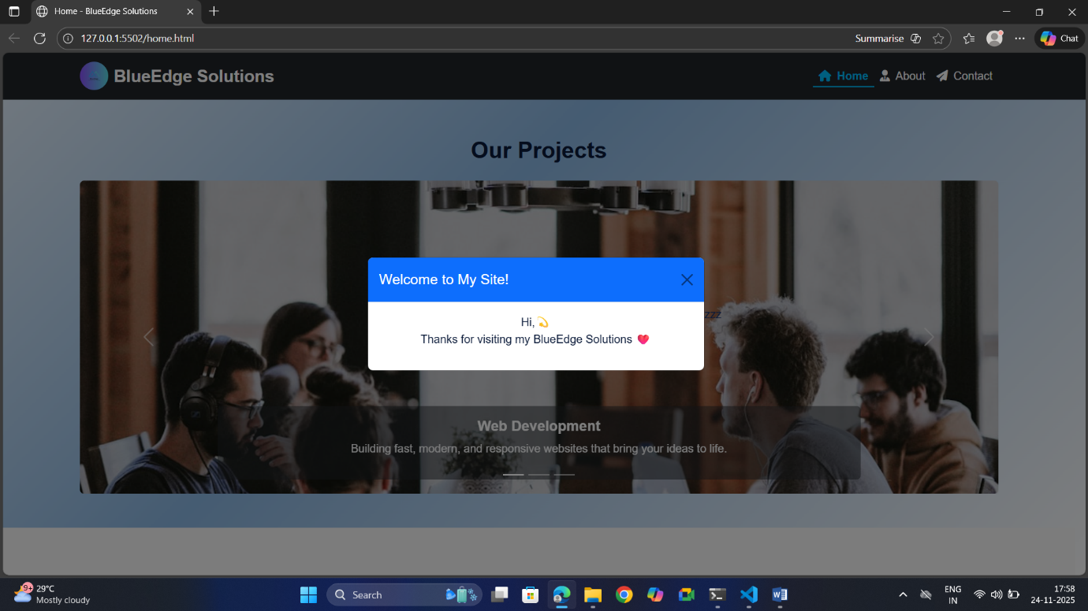

Remain:

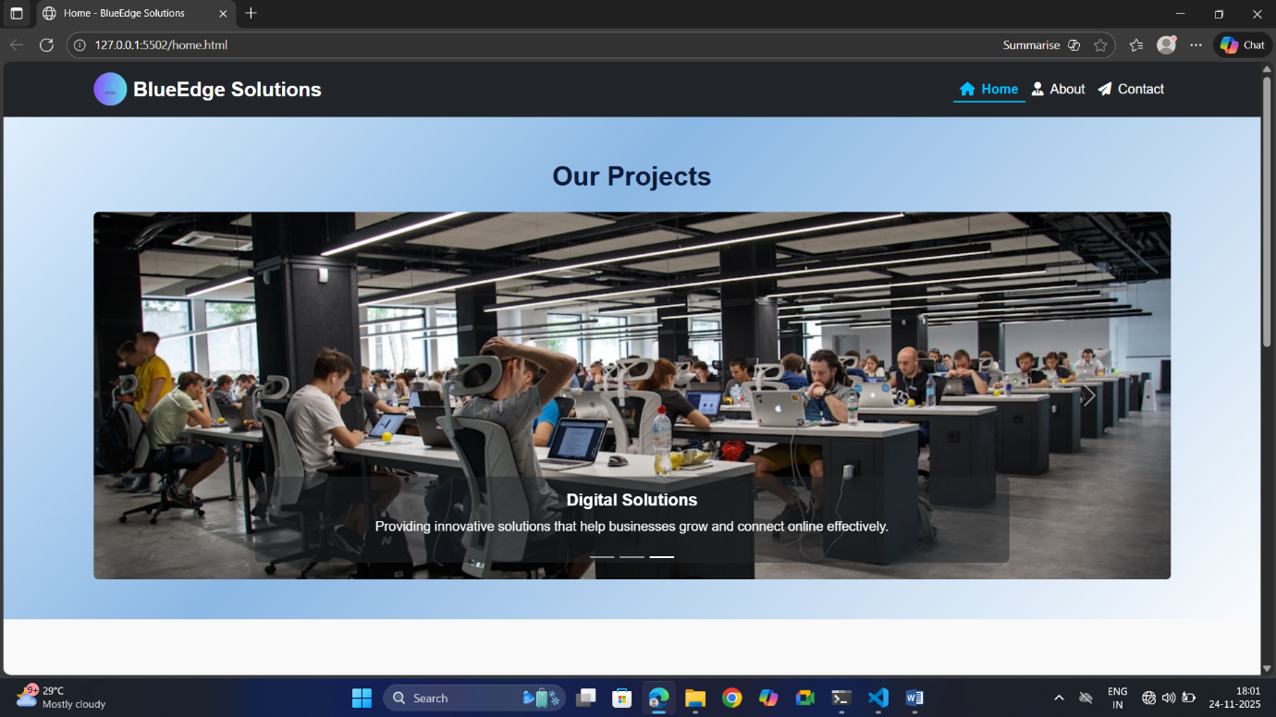

Remain:

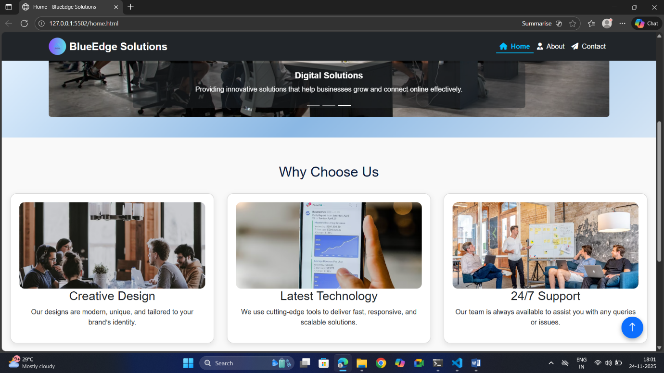 Remain:

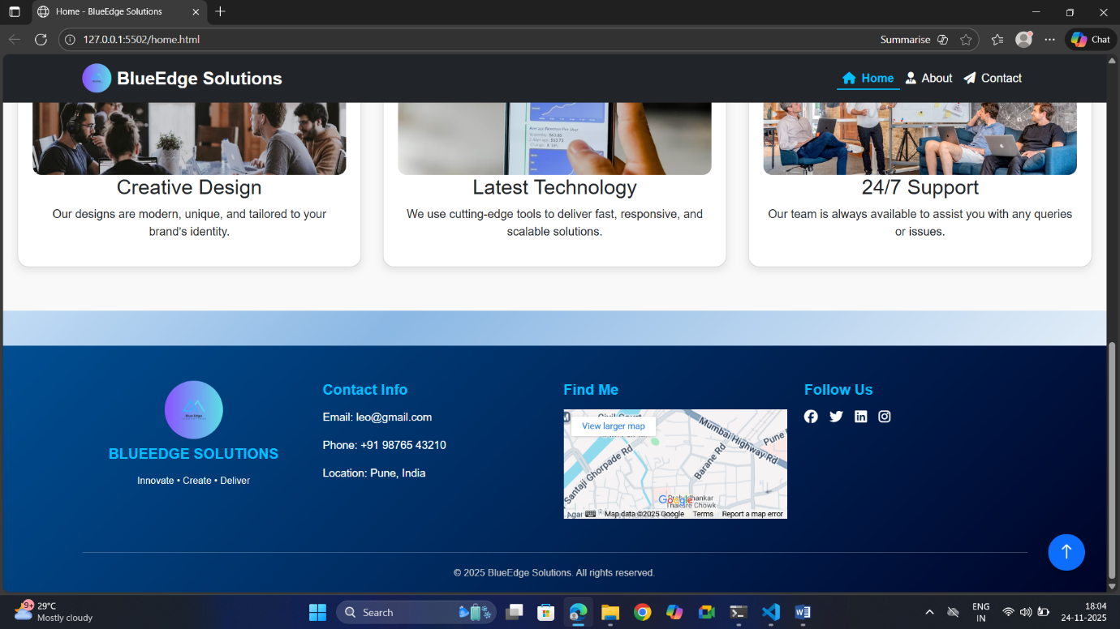

# OUTPUT-ABOUT PAGE:

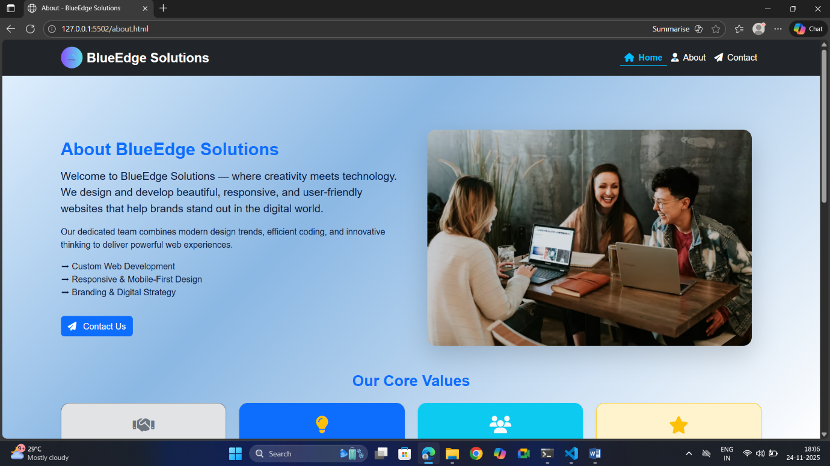

Remain:

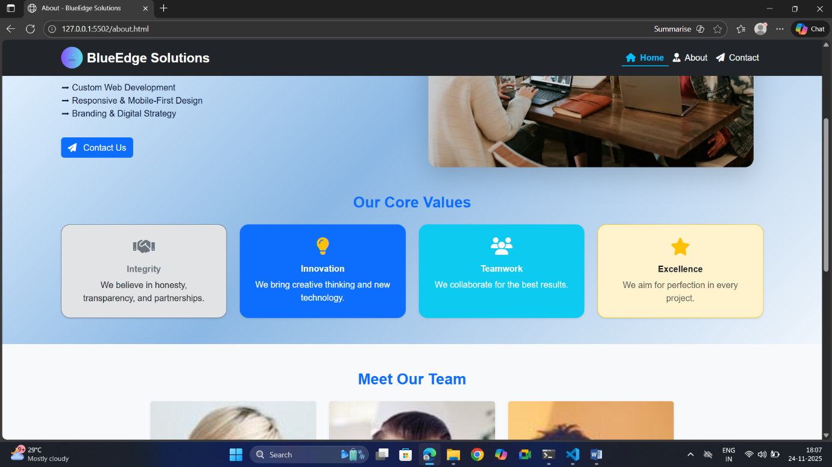

Remain:

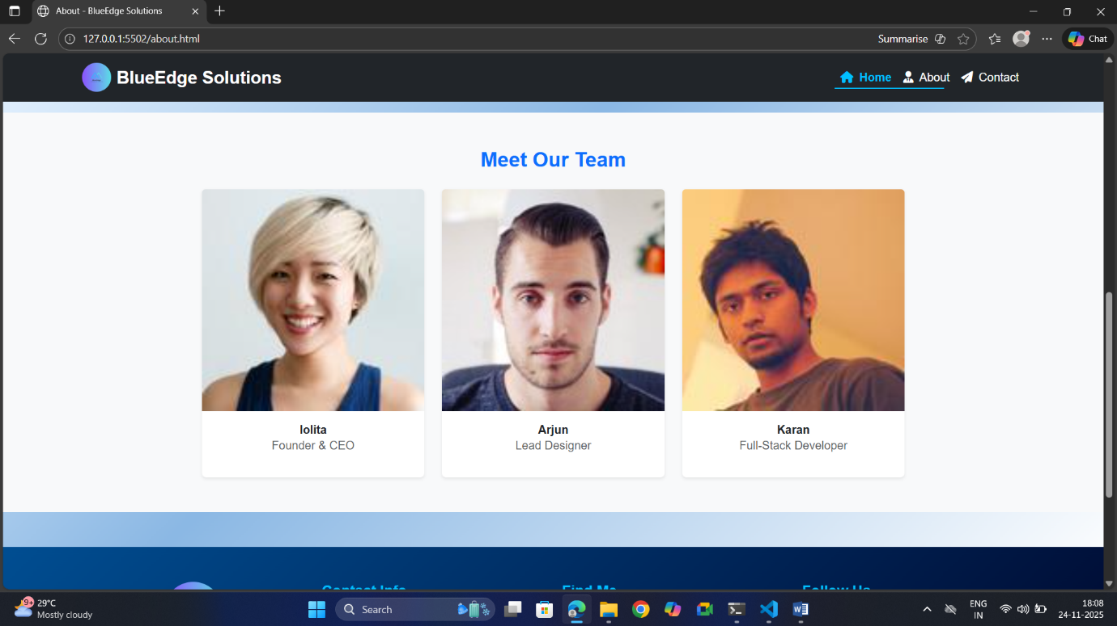

Remain:

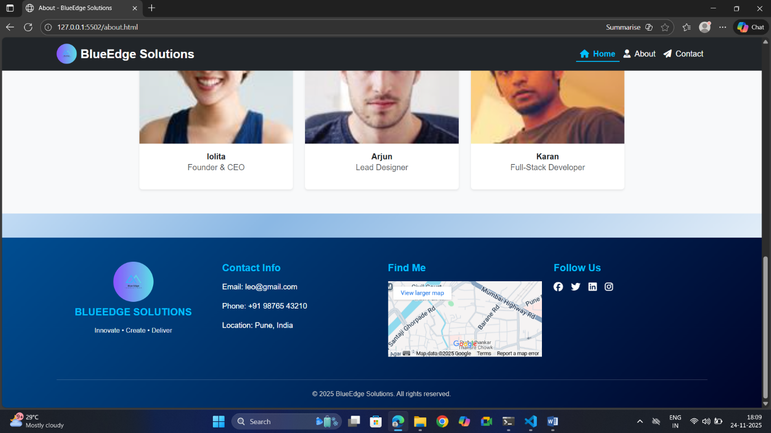

# OUTPUT-CONTACT PAGE:

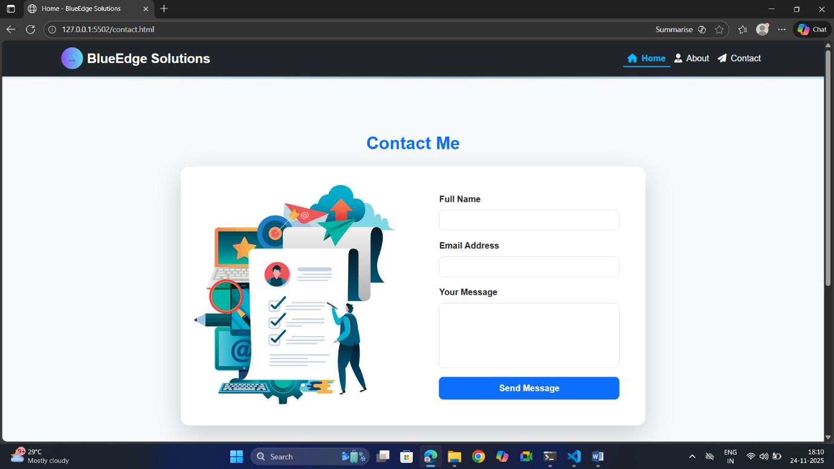

Remain:

